Order Of Service

Singing: Psalm 62—CW page 88

Reading: Psalm 78:56-64

Opening Hymn: TLH 63

Reading: Acts 12:12-19

Request Hymn: CW Supplement 769

Reading: John 21:20-25

Sermon Hymn: TLH 71

Sermon Text: Mark 1:01-03

Crying In The Wilderness

Prayer

The Apostles’ Creed, TLH page 12

Holy Communion

The Lord's Prayer

The Blessing

Closing Hymn: TLH 64

* * * * * * * * * * *

Bible Study: Lambs: Olive
Sheep: Romans 15:7-13
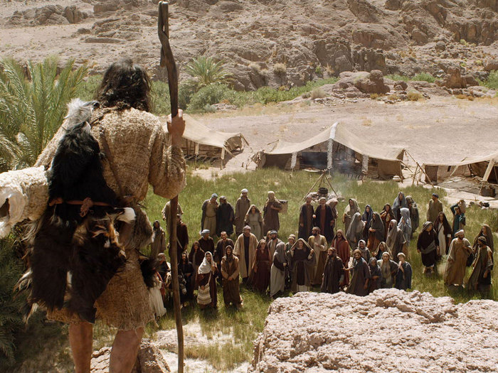

In The Wilderness

Water
Of
Life

26 August 2018

W A T E R O F L I F E

Independent Christian Church—Conservative Lutheran Doctrine

Worship Service: 9:30 a.m. Bible Study: 10:45 a.m.

Larry Cooper, Pastor E-Mail address:
111 N. Ridge Road lcooper@wateroflife.cc
Coon Valley, WI 54623 Web Site:
Phone: (608) 452-2105 www.wateroflife.cc

* * * * * * * * * * * * * * * * * * * * * * * * * * *

Sermon Text: Mark 1:01-03

Crying In The Wilderness

* * * * * * * * * * * * * * * * * * * * * * * * * * *
Mark 1:1 The beginning of the gospel of Jesus Christ, the Son of God;
:2 As it is written in the prophets, Behold, I send my messenger before thy face, which shall prepare thy way before thee.
:3 The voice of one crying in the wilderness, Prepare ye the way of the Lord, make his paths straight.

Related Reading—Matthew 1:1-17

1 The book of the generation of Jesus Christ, the son of David, the son of Abraham.
2 Abraham begat Isaac; and Isaac begat Jacob; and Jacob begat Judas and his brethren;
3 And Judas begat Phares and Zara of Thamar; and Phares begat Esrom; and Esrom begat Aram;
4 And Aram begat Aminadab; and Aminadab begat Naasson; and Naasson begat Salmon;
5 And Salmon begat Booz of Rachab; and Booz begat Obed of Ruth; and Obed begat Jesse;
6 And Jesse begat David the king; and David the king begat Solomon of her that had been the wife of Urias;
7 And Solomon begat Roboam; and Roboam begat Abia; and Abia begat Asa;
8 And Asa begat Josaphat; and Josaphat begat Joram; and Joram begat Ozias;
9 And Ozias begat Joatham; and Joatham begat Achaz; and Achaz begat Ezekias;
10 And Ezekias begat Manasses; and Manasses begat Amon; and Amon begat Josias;
11 And Josias begat Jechonias and his brethren, about the time they were carried away to Babylon:
12 And after they were brought to Babylon, Jechonias begat Salathiel; and Salathiel begat Zorobabel;
13 And Zorobabel begat Abiud; and Abiud begat Eliakim; and Eliakim begat Azor;
14 And Azor begat Sadoc; and Sadoc begat Achim; and Achim begat Eliud;
15 And Eliud begat Eleazar; and Eleazar begat Matthan; and Matthan begat Jacob;
16 And Jacob begat Joseph the husband of Mary, of whom was born Jesus, who is called Christ.
17 So all the generations from Abraham to David are fourteen generations; and from David until the carrying away into Babylon are fourteen generations; and from the carrying away into Babylon unto Christ are fourteen generations.

